1. **Important cautions**

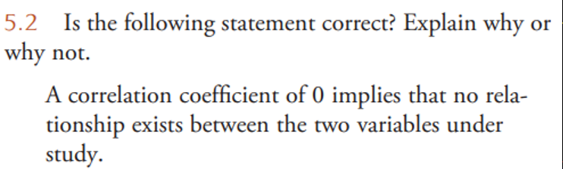

1. **Correlation & Causation**

**Example:** Most people love chocolate for its great taste. But does it also make you smarter?

A scatterplot like this one recently appeared in the New England Journal of Medicine. The explanatory variable is the chocolate consumption per person for a sample of countries. The response variable is the number of Nobel Prizes per 10 million residents of that country. 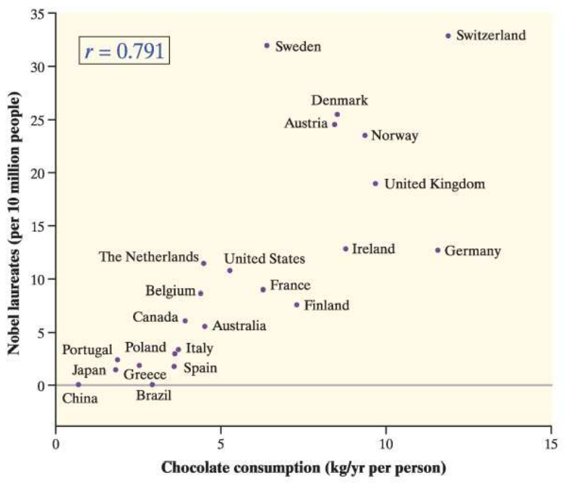

**a.** If people in the United States started eating more chocolate, could we expect more Nobel Prizes to be awarded to residents of the United States? Explain.

**b.** What effect does Switzerland have on the correlation? Explain.

1. **Calculate and Interpret r**

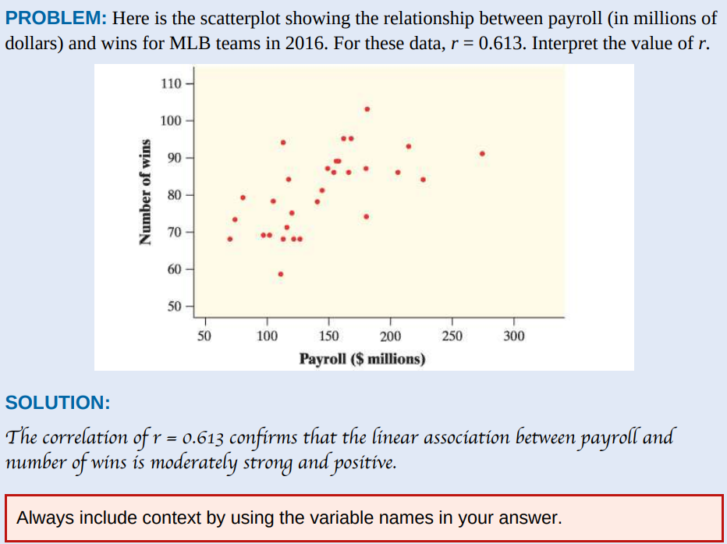**Example:**

计算机生成了可选文字:
5 ． 5 •The accompanying data are x = cost (cents per 
serving) and 丿 ' = fiber content (grams per serving) for 
18 high-fiber cereals rated by Consumer 心 or (www 
.consumerreports.org/health) ， 
Cost per 
50 、 'ing 
46 
62 
77 
71 
30 
67 
48 
28 
54 
27 
58 
Fiber per 
50 、 'ing 
10 
10 
12 
12 
10 
12 
14 

Compute and interpret the correlation coefficient for this data set.

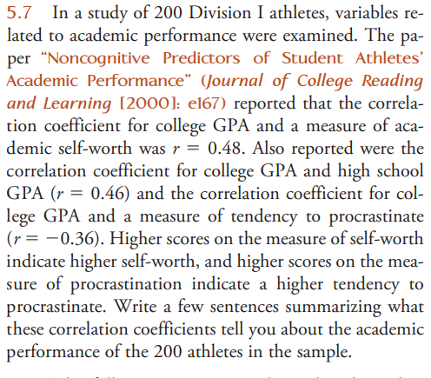

**MCQ:**

1. You have data for many years on the average price of a barrel of oil and the average retail price of a gallon of unleaded regular gasoline. If you want to see how well the price of oil predicts the price of gas, then you should make a scatterplot with ___________ as the explanatory variable.

a. the price of oil

b. the price of gas

c. the year

d. either oil price or gas price

e. time 30.

2. In a scatterplot of the average price of a barrel of oil and the average retail price of a gallon of gas, you expect to see

a. very little association.

b. a weak negative association.

c. a strong negative association.

d. a weak positive association.

e. a strong positive association.

3. The following graph plots the gas mileage (in miles per gallon) of various cars from the same model year versus the weight of these cars (in thousands of pounds). The points marked with red dots correspond to cars made in Japan. From this plot, we may conclude that

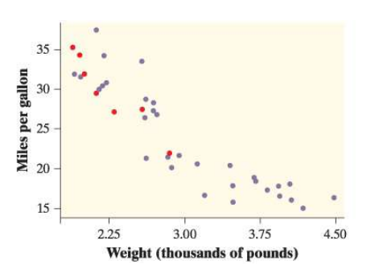

a. there is a positive association between weight and gas mileage for Japanese cars.

b. the correlation between weight and gas mileage for all the cars is close to 1.

c. there is little difference between Japanese cars and cars made in other countries.

d. Japanese cars tend to be lighter in weight than other cars.

e. Japanese cars tend to get worse gas mileage than other cars.

4. If women always married men who were 2 years older than themselves, what would be the correlation between the ages of husband and wife? a. 2

b. 1

c. 0.5

d. 0

e. Can’t tell without seeing the data

5. The scatterplot shows reading test scores against IQ test scores for 14 fifth-grade children. There is one low outlier in the plot. What effect does this low outlier have on the correlation?

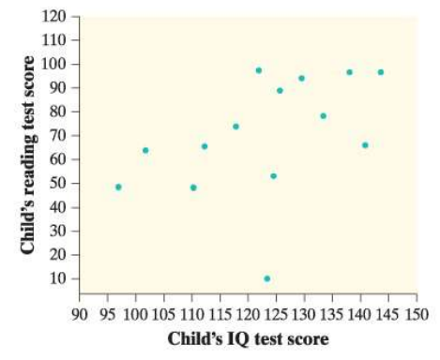

a. It makes the correlation closer to 1.

b. It makes the correlation closer to 0 but still positive.

c. It makes the correlation equal to 0.

d. It makes the correlation negative.

e. It has no effect on the correlation.

6. If we leave out the low outlier, the correlation for the remaining 13 points in the preceding figure is closest to

a. −0.95.

b. −0.65.

c. 0.

d. 0.65.

e. 0.95.